

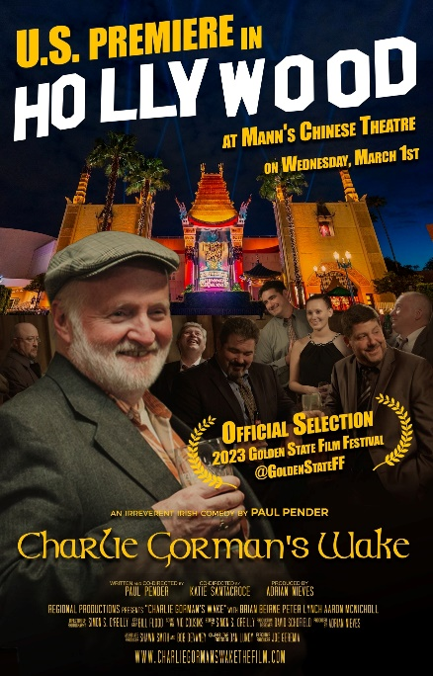***FOUNDED MARCH 1971*** [***WWW.IRISHHISTORYROUNDTABLE.ORG***](http://WWW.IRISHHISTORYROUNDTABLE.ORG) ***November 2023***

**Charlie Gorman’s Wake**

For our November 21st meeting of the IHRT, Paul Pender, writer and co- director of the locally made film, Charlie Gorman’s Wake, will show us this film. The film lasts 86 minutes and fits into our meeting time perfectly. It tells the story of the patrons of Gorman’s Bar in the sleepy County Kildare village of Ballycarraig and their plot to have a wake. Join us at 7:30pm at the Knights of St. Patrick hall at State St., New Haven for a drink and movie night at the IHRT.

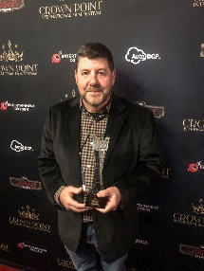 Pender made this film with local actors, including our own IHRT member, Terry Remeika, and won the prestigious California Crown Point International Film Festival’s Best of Fest and Best Comedy Feature.

**COMING EVENTS :**

**Irish Book Club is reading a fiction book, The Colony by Audrey McGee. Meeting on December 7 at 4:15pm at a member’s home. Contact: 203.288.9035 if interested.**